Test Process Metrics

🔹 Definition
# Source: Chatgpt (GPT-5-Standard) at [8/18/2025]
Test Process Metrics are measures that track and evaluate the efficiency, effectiveness, and progress of the testing activities throughout the Software Testing Life Cycle (STLC).
They help teams monitor how well testing is being performed, ensure goals are met, and identify areas for improvement.

🛠️ Key Test Process Metrics

1. Test Case Execution Metrics
# Source: Chatgpt (GPT-5-Standard) at [8/18/2025]
- Description: Measures the status of executed test cases.
- Example Values:
  - Total test cases planned = 500
  - Executed = 450
  - Passed = 400 (89%)
  - Failed = 50 (11%)
📌 Insight: Helps check progress and quality of testing.

2. Test Coverage
# Source: Chatgpt (GPT-5-Standard) at [8/18/2025]
- Description: Percentage of requirements, features, or code covered by tests.
- Formula:
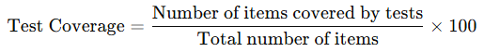
Test Coverage=Number of items covered by testsTotal number of items×100\text{Test Coverage} = \frac{\text{Number of items covered by tests}}{\text{Total number of items}} \times 100
- Example: 90% requirements covered by test cases.
📌 Insight: Higher coverage = reduced risk of missing defects.

3. Defect Detection Percentage (DDP)
# Source: Chatgpt (GPT-5-Standard) at [8/18/2025]
- Description: Effectiveness of defect detection during testing.
- Formula:
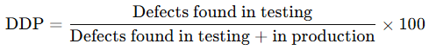
DDP=Defects found in testingDefects found in testing + in production×100\text{DDP} = \frac{\text{Defects found in testing}}{\text{Defects found in testing + in production}} \times 100
- Example: 95% DDP → strong testing process.

4. Test Progress Tracking
# Source: Chatgpt (GPT-5-Standard) at [8/18/2025]
- Description: Measures progress against the test plan.
- Example:
  - Planned tests for Week 1: 200
  - Executed: 150 → Progress = 75%
📌 Insight: Helps track schedule adherence.

5. Test Effort Variance
# Source: Chatgpt (GPT-5-Standard) at [8/18/2025]
- Description: Compares planned effort vs actual effort spent in testing.
- Formula:
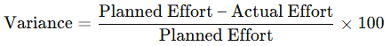
Variance=Planned Effort – Actual EffortPlanned Effort×100\text{Variance} = \frac{\text{Planned Effort – Actual Effort}}{\text{Planned Effort}} \times 100
- Example: Planned = 200 hours, Actual = 220 hours → -10% variance.
📌 Insight: Helps in future estimation improvements.

6. Defect Turnaround Time
# Source: Chatgpt (GPT-5-Standard) at [8/18/2025]
- Description: Average time to fix and retest a defect.
- Example:
  - Defect reported → fixed in 3 days → retested in 1 day.
📌 Insight: Shows efficiency of defect handling.

📊 Example Summary (Web App Project)
# Source: Chatgpt (GPT-5-Standard) at [8/18/2025]
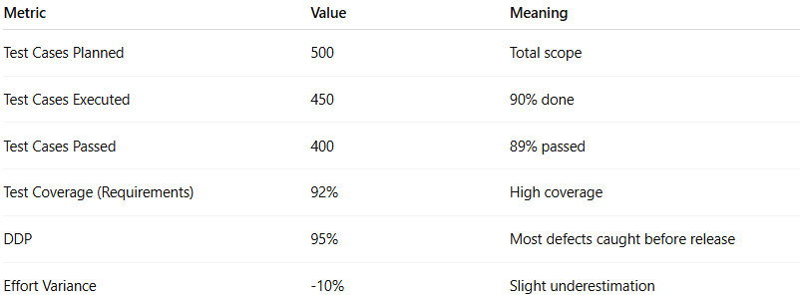
Metric | Value | Meaning
Test Cases Planned | 500 | Total scope
Test Cases Executed | 450 | 90% done
Test Cases Passed | 400 | 89% passed
Test Coverage (Requirements) | 92% | High coverage
DDP | 95% | Most defects caught before release
Effort Variance | -10% | Slight underestimation

✅ Why Test Process Metrics Matter
# Source: Chatgpt (GPT-5-Standard) at [8/18/2025]
- Show progress of testing work.
- Identify bottlenecks (e.g., slow defect resolution).
- Improve future planning & estimation.
- Provide objective evidence of testing quality.

👉 In short:
Test Process Metrics = measures that track test progress, coverage, effort, and defect detection efficiency to ensure testing is on track and effective.

